Software Requirement System

Greenhouse Farm Website

Asiedu- Danquah Yaw Osei (5948016)

Michael Gyimah (5951916)

Nnuro Steven Kofi (5953616)

Brenden Asare (5947616)

Afful Franccis Baah Amponsah(5945616)

Asamoah Cyril Mawunyo (5948416)

Goode Kyereme Richmond(5951316)

Table of Contents  
1.Introduction...............................................................................................................................................1  
1.1 Purpose................................................................................................................................................1  
1.2 Scope...................................................................................................................................................1  
1.3 Definitions, acronyms, and abbreviations...........................................................................................1  
1.4 References...........................................................................................................................................2  
2. Overall description....................................................................................................................................4  
2.1 Product perspective.............................................................................................................................4  
2.2 Product functions ................................................................................................................................4  
2.3 User characteristics .............................................................................................................................5  
2.4 Constraints ..........................................................................................................................................5  
2.5 Assumptions and dependencies ..........................................................................................................5  
2.6 Apportioning of requirements.............................................................................................................6  
3. Specific requirements................................................................................................................................7  
3.1.1 User interfaces .............................................................................................................................7  
3.1.2 Hardware interfaces .....................................................................................................................8  
3.1.3 Software interfaces.......................................................................................................................8  
3.1.4 Communications interfaces..........................................................................................................9  
3.2 Functional requirements......................................................................................................................9  
3.2.1 User Class 1 - The User ...............................................................................................................9  
3.2.2 User Class 2 - Farmer Owner ...............................................................................................14  
3.2.3 User Class 3 - Administrator......................................................................................................18  
3.3 Performance requirements ................................................................................................................21  
3.4 Design constraints.............................................................................................................................23  
3.5 Software system attributes ................................................................................................................23  
4. Prioritization and Release Plan ...............................................................................................................27  
4.1 Choice of prioritization method ........................................................................................................27  
Appendix I: Selection for Cost-Value Approach........................................................................................29  
Appendix II: Prioritization Result of 10 selected Requirements Using Cost-Value Approach ..................32  
Appendix III: Five-Way Priority Scheme...................................................................................................36  
Appendix IV: Release Plan.........................................................................................................................47  
Appendix V: I-star ......................................................................................................................................55

1. **Introduction** This documentation gives a scope description and overview of what the project is about.This document is also well described and a list of abbreviations and definitions is provided.

**1.1 Purpose** The purpose of this document is to give a detailed description of the requirements for the “Greenhouse Farm Website” and how it will be used . It will illustrate the purpose and complete description for the development of the website. It will also explain system constraints, interface and interactions with other external applications. This document is primarily intended to be proposed to a customer for its approval and a reference for updating the website for the development team.

**1.2 Scope** The “Greenhouse Farm Website” is a website which helps people to buy and sell foodstuffs such as vegetables, fruits etc, based on the user’s current position and other specification like price, dish and more.Farm owners can provide their greenhouse information using the web-portal. This information will act as the bases for the search results displayed to the user. An administrator also uses the web-portal in order to administer the system and keep the information accurate. The administrator can, for instance, verify the farmer and manage user information.  
 Furthermore, the website needs both the internet and process tracker to fetch and display results. All system information is maintained in a database, which is located on a web-server. The website also interacts with the process tracker which is required to be an already installed application on the website. By using the process tracker, users can determine the progress of the processing of their products and when exactly they will receive them. The application also has the capability of representing both summary and detailed information.

**1.3 Definitions, acronyms, and abbreviations**

|  |  |
| --- | --- |
| Term | Definition |
| Greenhouse | Is a structure enclosed and used for the cultivation or protection of tender plants. |
| GHG | Greenhouse Gas |
| GHGRP | Greenhouse Gas Emission Reporting Program |
|  |  |
|  |  |
|  |  |

**1.4 References**

**1.5 Overview** The remainder of this document includes three chapters and appendixes. The second one provides an overview of the system functionality and system interaction with other systems. This chapter also introduces different types of farmers and their interaction with the system and also user interactions. Further, the chapter also mentions the system constraints and assumptions about the website.The third chapter provides the requirements specification in detailed terms and a description of the different system interfaces.

Different specification techniques are used in order to specify the requirements more precisely for different audiences.The fourth chapter deals with the prioritization of the requirements. It includes a motivation for the chosen prioritization methods and discusses why other alternatives were not chosen.  
 The Appendixes in the end of the document include the all results of the requirement prioritization and a release plan based on them.

1. **Overall description** This section will give an overview of the website. The website will be explained in its context to show how the website interacts with other websites and introduce the basic functionality of it. It will also describe what type of farmer that will use the website and what functionality is available for each type. At last, the constraints and assumptions for the website will be presented.
   1. **Product perspective**This system will consist of one part: one web portal. The web portal will be used for managing the information about the greenhouse farms and also help place orders for delivery.  
      The web portal will need to communicate to a process tracker within the website. Since this is a data-centric product it will need somewhere to store the data. For that, a database will be used. Web portal will communicate with the database, however in slightly different ways. The web portal will only use the database to get data and will also add and modify data. All of the database communication will go over the Internet.
   2. **Product functions**With the web portal, the users will be able to search for products greenhouse farms. The result will be based on the criteria the user inputs. There are several search criteria and it will be possible for the administrator of the system to manage the options for those criteria that have that.The result of the search will be viewed either in a list view or in a map view, depending on what criteria included in the search. The list view will have one list item for each greenhouse farm matching the search criteria and show a small part of the farm information so the user can identify the greenhouse farm. The map view will show each greenhouse farm location as a pin on the map as well as the user’s own location. In both views the users will be able to either select a greenhouse farm as target destination or get information how to get there, or view the information of a specific farm.The web portal will provide functionality to manage the system and the restaurant information. It will also provide information about the website, for example show when there is a new update.
   3. **User characteristics**There are three types of users that interact with the system: users, greenhouse farm owners and administrators. Each of these three types of users has different use of the system so each of them has their own requirements.The web portal users can only use the application to find a greenhouse farm. This means that the user have to be able to search for farms, choose a greenhouse farm from that search and then navigate to it. In order for the users to get a relevant search result there are multiple criteria the users can specify and all results matches all of those.The greenhouse farm owners will also us the web portal. There they will manage the information about their farm, for example a description of the farm,contact information and their menu.The administrators also only interact with the web portal. They are managing the overall system so there is no incorrect information within it. The administrator can manage the information for each greenhouse farm as well as the options for both the mobile application users and the greenhouse farm owners.

**2.4 Constraints**The website is constrained by the system interface to the process tracker with the user’s particular location. Since there are multiple system and multiple process trackers, the interface will most likely not be the same for every one of them.  
The Internet connection is also a constraint for the website. Since the website fetches data from the database over the Internet, it is crucial that there is an Internet connection for the application to function.

**2.5 Assumptions and dependencies**One assumption about the product is that it will always be used on mobile phones or any computing device that have enough performance. If the phone does not have enough hardware resources available for the website, for example the users might have allocated them with other applications, there may be scenarios where the website does not work as intended or even at all.  
Another assumption is that the process tracker in all phones and other computing devices work in the same way. If the phones have different interfaces to the process tracker, the application need to be specifically adjusted to each interface and that would mean the integration with the process tracker would have different requirements than what is stated in this specification.

**2.6 Apportioning of requirements**In the case that the project is delayed, there are some requirements that could be transferred to the next version of the application. Those requirements are to be developed in the third release, see Appendix IV

1. **Specific requirements**This section contains all of the functional and quality requirements of the website. It gives a detailed  
   description of the website and all its features.

**3.1 External interface Requirements**This section provides a detailed description of all inputs into and outputs from the system. It also gives a  
description of the hardware, software and communication interfaces and provides basic prototypes of the  
user interface.

.  
3.1.1 User interfaces  
A first-time user of the web portal should see the log-in page when he/she opens the website page ,  
see Figure 2. If the user has not registered, he/she should be able to do that on the log-in page.  
If the user is not a first-time user, he/she should be able to see the search page directly when the  
website is opened, see Figure 3. Here the user chooses the type of search he/she wants to conduct.  
Every user should have a profile page where they can edit their e-mail address, phone number and  
password, see Figure 4. Also, the user can set the website to his/her preferred language. The  
“P” icon shows where the user can click to navigate to his/her profile page.  
In Figure 5, the list view for the results is shown. When a user searches by price, this view should be the  
default one. The sorting header allows the user to sort the results according to price, farmer name,  
distance, restaurant type and specific foodstuffs. Each result item includes information about the greenhouse farm, a link to the greenhouse web-page and an information link, which provides a more detailed description of the greenhouse. There is also a filtering option, where the user can choose to filter the results by increasing  
or decreasing the price or distance range, see Figure 7.  
In the map view each greenhouse farm is represented by a pin, see Figure 6. Next to every pin there is an  
information link which provides a more detailed description of the greenhouse, as mentioned for the list  
view. The same filtering option, as for the list view, is included in the map view.

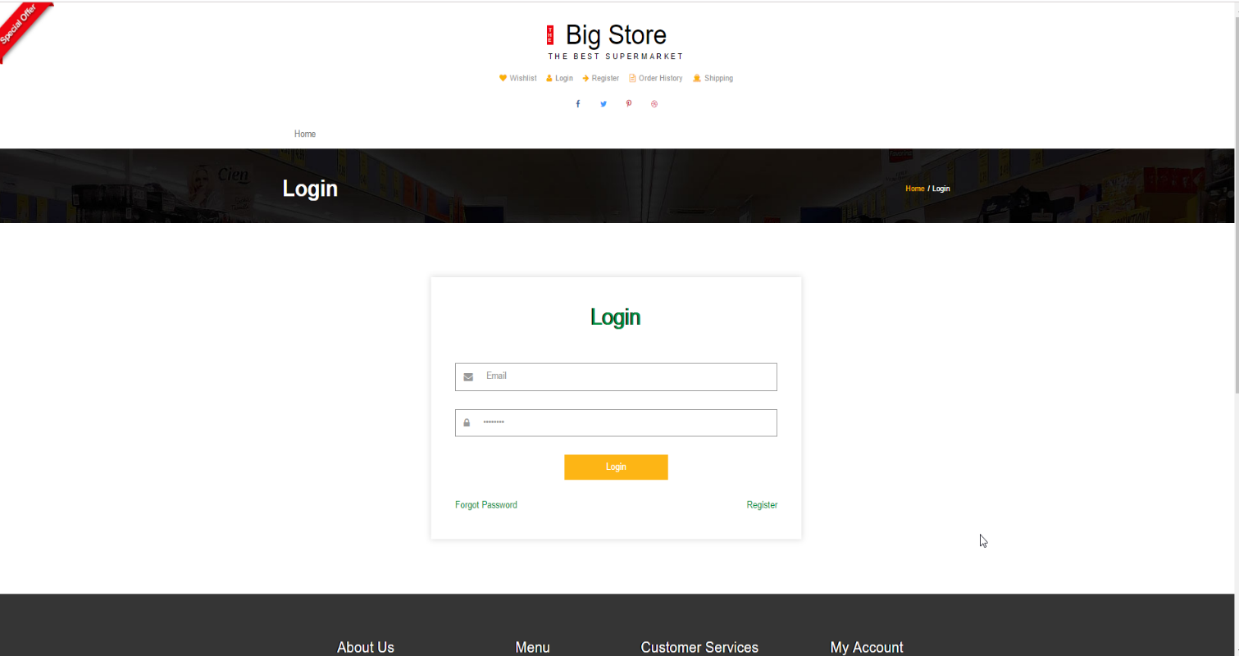

Fig 2.

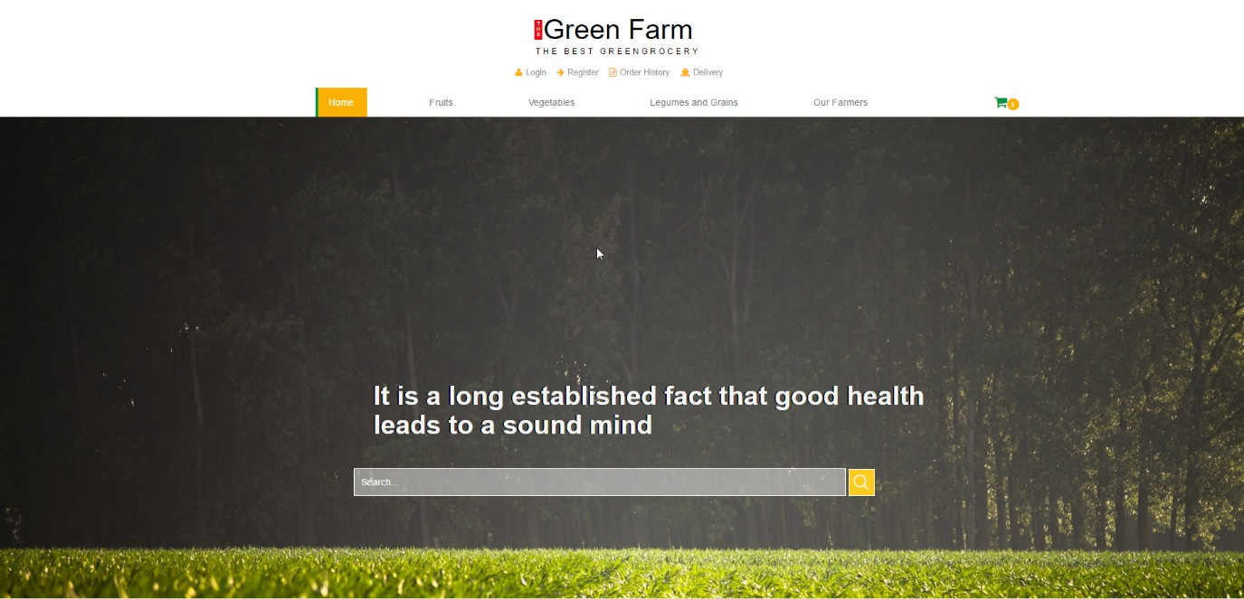

Fig 3. Search on the homepage

**Figure 2 - Login page Figure 3 – Search page Figure 4 – Profile page** 8  
The greenhouse and administrators interact with the system through a web-portal, see Figure 8. A  
greenhouse farmer should be able to register on the web-portal in order to log in and manage the restaurant  
information. An administrator should also be able to log in to the web-portal where he/she can administer  
the system by for instance editing restaurant or user information.

**3.1.2 Hardware interfaces**Since neither the mobile application nor the web portal have any designated hardware, it does not have  
any direct hardware interfaces. The physical GPS is managed by the GPS application in the mobile phone  
and the hardware connection to the database server is managed by the underlying operating system on the  
mobile phone and the web server.  
**3.1.3 Software interfaces**The mobile application communicates with the GPS application in order to get geographical information  
**Figure 5 – List view Figure 6 – Map view  
Figure 8 – Web Portal  
Figure 7 – Filter menu**  
9  
about where the user is located and the visual representation of it, and with the database in order to get the  
information about the restaurants, see Figure 1. The communication between the database and the web  
portal consists of operation concerning both reading and modifying the data, while the communication  
between the database and the mobile application consists of only reading operations.

**3.1.4 Communications interfaces**The communication between the different parts of the system is important since they depend on each  
other. However, in what way the communication is achieved is not important for the system and is  
therefore handled by the underlying operating systems for both the mobile application and the web portal.